WELDED WIRE WALL
Differential Settlement & Compressible Facing

Some of the main reasons Hilfiker’s Welded Wire Wall (WWW) is well-liked and chosen over other types of MSE systems are:
- It is a flexible-faced structure; settlement is generally not an issue, unlike concrete structures which will crack with settlement. We don’t.
- It is cost-efficient, both from a material procurement and installed-cost standpoint.
- It is strong and durable and can handle an incredible amount of abuse and movement.

Compressible Facing
Hilfiker Retaining Walls developed the compressible facing for the WWW in the mid-90’s, which mitigates post-construction bulging in the layers and facing deformation. This feature allows our walls to accommodate differential settlement, and also has labor and equipment advantages during construction. Some agencies have since adopted and required this feature in their project specifications for wire-faced walls. In general, Hilfiker Walls with wire mesh reinforcement [transverse and longitudinal wires] are better able than other MSE soil systems to withstand differential settlement, lateral movement, and other types of abuse.

The first project utilizing this system improvement:
SR 101, MP 321 and 322 Vic. Slide (HRW: 000407BW); Mason County, WA; Shipped July 2000
Contractor: Bruch & Bruch
Owner: Washington State Department of Transportation
Product: Welded Wire Retaining Wall – 24,320 SF
Within a year of completion, an earthquake occurred with an epicenter near the wall location. The wall was inspected and there were no visible signs of deflection or movement.

The Hilfiker WWW has a compression allowance of 3 inches built into each 24” horizontal lift. The backing mat is an important structural component to the wall system, and provides stiffness in the face as well as continuity across the standard mat joints. The backing mat is installed with hog rings and placed at the face with a 3” vertically spaced gap (detail below). After installation, if the lift were to settle 3”, then the hog ring would give way allowing the backing mat to drop down to the soil reinforcement but still keep the face stiff enough to not cause deformation.

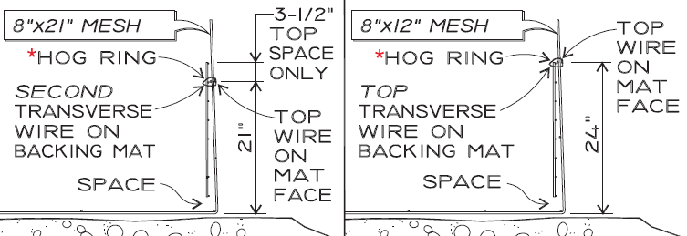

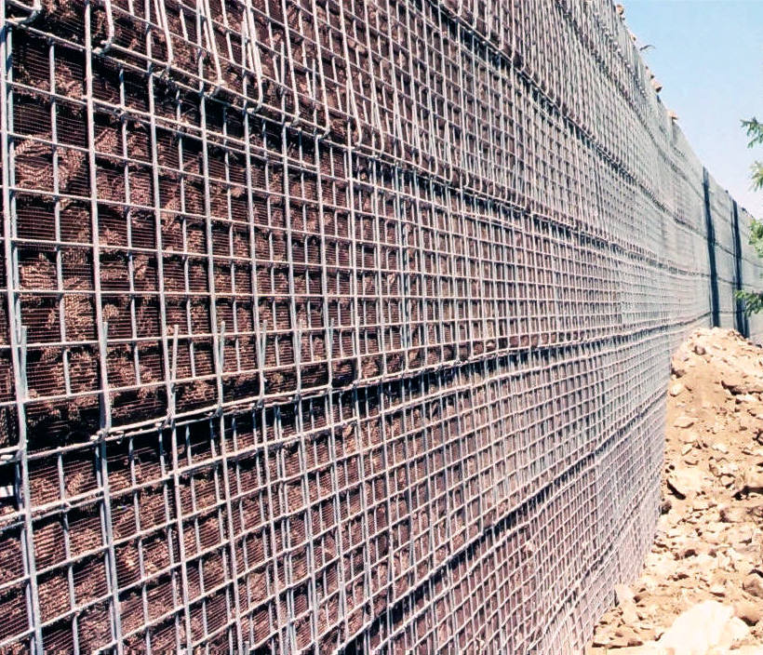

Maximum Measured Settlement - Bangkok Welded Wire Test Wall
A full-scale and extensively instrumented experimental MSE wall with steel grid reinforcements was built on soft clay foundation. Three different locally available poor to marginal quality backfills were used in each of three sections along its length. The soft Bangkok clay in the subsoil is about 6 m thick, overlain by a surficial 2 m thick weathered clay crust and underlain by a layer of stiff clay. It was observed that the amount of subsoil movement greatly influenced the variation in the vertical pressure beneath the wall, as well as the tension in the reinforcement. Pullout resistances in the field were also found to be very much affected by the arching effects due to the presence of inextensible reinforcement in combination with the subsoil movements. The wall showed no signs of instability both during construction and in the post-construction phases, despite the large settlements and lateral movements. Its overall performance has been satisfactory. It was concluded that the steel grid reinforcement can be effectively used to reinforce poor to marginal quality backfill in walls and embankments on soft clay foundations.

The maximum lateral movement in the subsoil occurred at a depth of about 3 m below the general ground level in the soft clay layer, corresponding to the weakest zone in the subsoil. The magnitudes of the surface settlements were found to be the highest, followed by the subsurface settlements at 3 m depth and, lastly, the subsurface settlements at 6 m depth, at or near the same area beneath the embankment/wall system.

Bangkok, Thailand; Asian Institute of Technology, c/o Dr. D.T. Bergado
Welded Wire Wall – 2,064 SF; April 1989
Link to Dr. D.T. Bergado’s, Asian Institute of Technology, Thesis: http://pdf.usaid.gov/pdf_docs/PNABJ854.pdf

Construction, Backfill, and Expected Deflection
Hilfiker’s strong WWW system is just one factor that contributes to a successful MSE installation project. Contractor performance, proper construction, and use of specified backfill are all important contributing factors as well. Maximum deflection isn’t so much related to the MSE wall type, but is more contingent upon a proper design specific to the site conditions and soil properties, a good strong foundation, proper backfill compaction and quality construction for the installation. If all those items are achieved and meet the provided specifications, then lateral movement is not expected.

As a materials supplier, Hilfiker cannot quantify the chosen contractors’ installation work. Extremely tall mining structures with extreme surcharges have been installed very well with high quality backfill and haven’t moved since, yet on the other side poorly constructed walls have resulted in just as poor post-installation performance. It is the same Welded Wire Wall material supplied, but different backfill and/or installation and therefore a different result. Construction quality control is imperative.

More technical information on the topic can be found in the Federal Highway Administration’s Publication No. FHWA-NHI-10-024 (https://www.fhwa.dot.gov/engineering/geotech/pubs/nhi10024/nhi10024.pdf), which is a widely-used design document detailing these types of performance criteria at length. Intuitively, an inextensible, steel system would have more stiffness and therefore less prone to deflection, over an extensible geogrid or geotextile reinforced system.

Strongest Option
Hilfiker’s WWW system is very well suited for applications with significant surcharge, and/or when settlement is expected. The soil reinforcement and facing are fabricated out of a single unit (non-extensible welded wire mesh). This greatly simplifies the alignment and batter control in the erection of the system, and allows for optimum speed in the backfill placement and compaction operation. With this system being “non-extensible,” it is the stiffest M.S.E. structure you can get. When our wall is combined with the appropriate backfill and quality construction, you will have an extremely rigid and durable structure.

